**Day 8 – Python Session – Accenture bootcamp**

**Name: Pothumulla Kankanamge Mewan Madhusha**

Table of Contents

Task 01 3

Task 2 6

List Operations: 6

Dictionary Operations: 9

Combining Lists and Dictionaries: 13

Extra work(hands-on experience) 17

List 17

Dictionary 18

# Task 01

Please create a document, write a Python program, and share it in this chat.

Fibonacci Sequence

Factorial Calculation

Prime Numbers

Palindrome Check

Answer

# Fibonacci Sequence

# Factorial Calculation

# Prime Numbers

# Palindrome Check

def fibonacci(numOfterms):

fibo_seq = [0,1]

while len(fibo_seq) < numOfterms:

fibo_seq.append(fibo_seq[-1] + fibo_seq[-2])

return fibo_seq[:numOfterms]

def factorial(num):

if num == 0 or num == 1:

return 1

return num * factorial(num - 1)

def prime_numbercheck(num):

if num < 2:

return False

for i in range(2, int(num**0.5) + 1):

if num % i == 0:

return False

return True

# i have just used python reversed string function

def is_palindrome(word):

return word == word[::-1]

def main():

while True:

print("\nChoose an operation:")

print("1. Fibonacci Sequence")

print("2. Factorial Calculation")

print("3. Prime Numbers Check")

print("4. Palindrome Check")

print("5. Exit")

choice = input("Enter the number of your choice (1-5): ")

if choice == '1':

n = int(input("Enter the number of terms for the Fibonacci sequence: "))

result = fibonacci(n)

print(f"Fibonacci Sequence: {result}")

elif choice == '2':

num = int(input("Enter a number to calculate its factorial: "))

result = factorial(num)

print(f"Factorial of {num}: {result}")

elif choice == '3':

num = int(input("Enter a number to check if it's prime: "))

result = prime_numbercheck(num)

print(f"{num} is {'prime' if result else 'not prime'}.")

elif choice == '4':

word = input("Enter a word to check if it's a palindrome: ").lower()

result = is_palindrome(word)

print(f"{word.capitalize()} is {'a palindrome' if result else 'not a palindrome'}.")

elif choice == '5':

print("Exiting the program. Goodbye!")

break

else:

print("Invalid choice. Please enter a number between 1 and 5.")

if __name__ == "__main__":

main()

Output answers

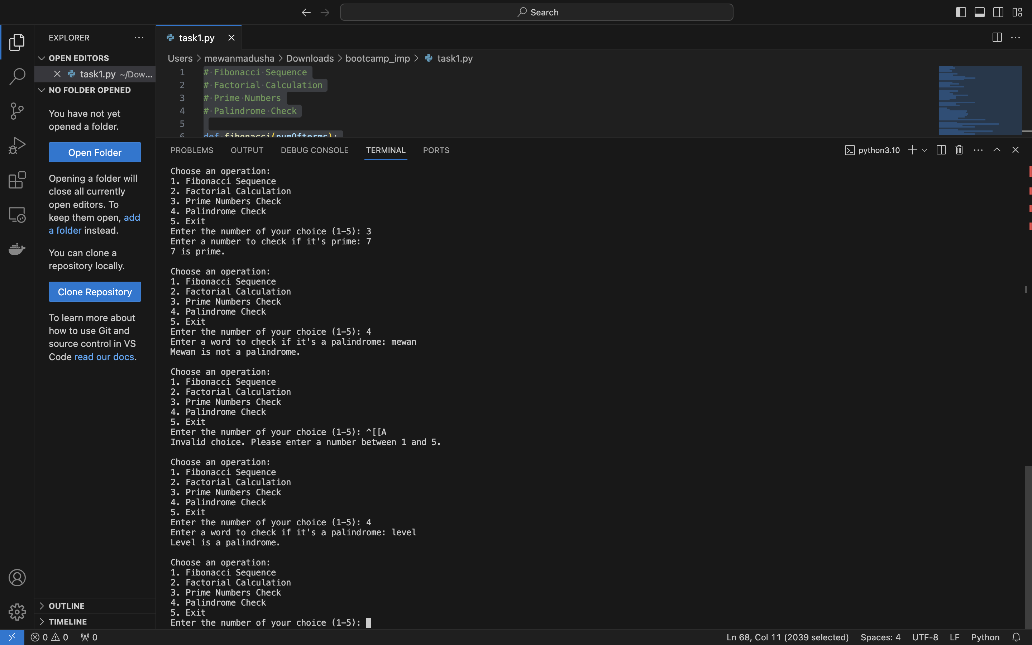

# Task 2

Complete this task. You can seek help online, but if you understand the process, feel free to proceed. Otherwise, note down your questions, and we will discuss them in the end-time session.

## List Operations:

1. Write a Python function to find the maximum value in a list of numbers.

def find_max_value(n_list):

return max(n_list)

num_list = [15, 7, 22, 45, 18, 32]

max_value = find_max_value(num_list)

print("Maximum value in the list:", max_value)

Answer

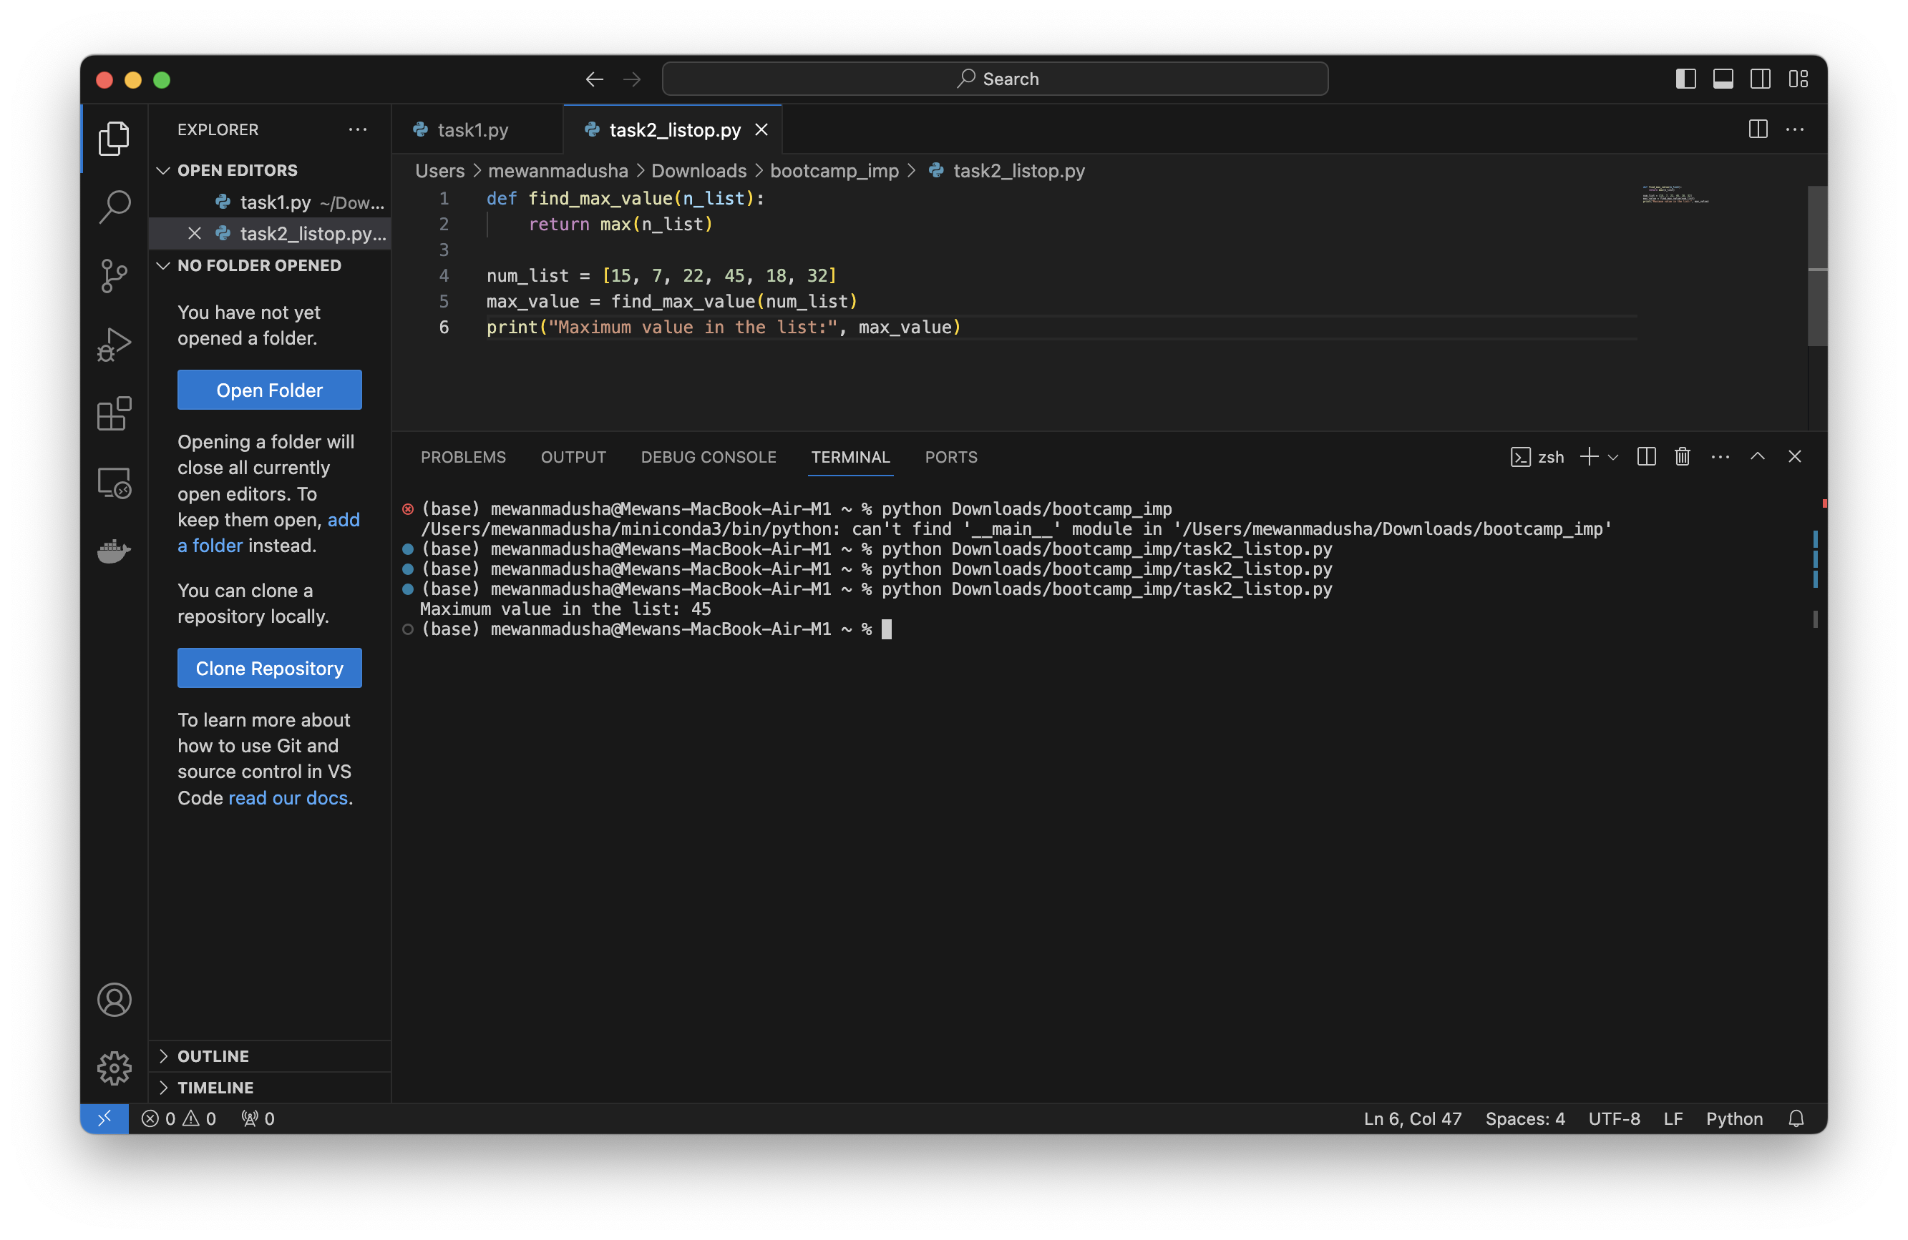

1. append, Extend and Insert works explain in code.

# append: Adding an element to the end of the list

aei_list = [1, 2, 3]

aei_list.append(4)

print("aie_list after append:", aei_list)

# Extend: Adding elements from an iterable to the end of the list

aei_list.extend([5, 6, 7])

print("aie_list after extend:", aei_list)

# Insert: Inserting an element at a specific index in the list(we should mention the index)

aei_list.insert(1, 8)

print("aie_list after insert:", aei_list)

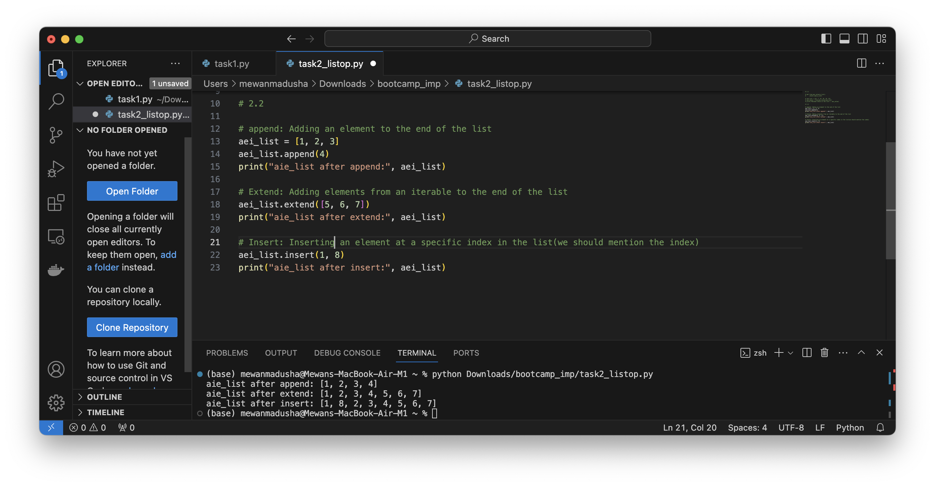

1. Implement a program to remove duplicates from a given list.

def remove_duplicates(n_lst):

return list(set(n_lst))

# Example usage:

first_list = [1, 2, 2, 3, 4, 4, 5]

unique_list = remove_duplicates(first_list)

print("List with duplicates:", first_list)

print("List without duplicates:", unique_list)

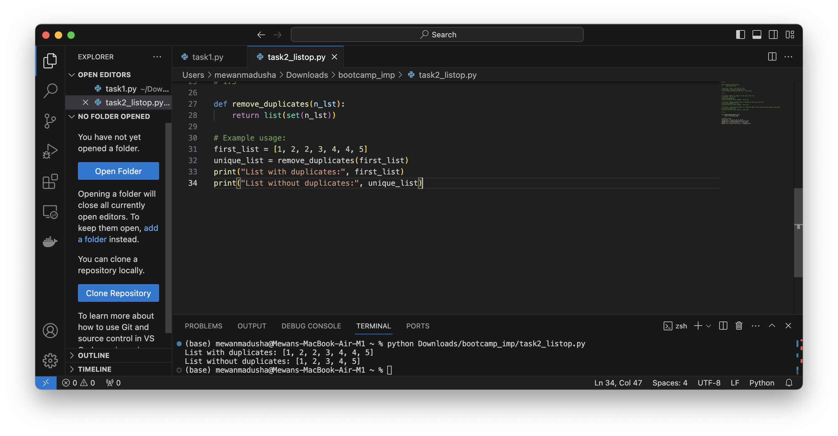

1. Create a function to check if a list is sorted in ascending order.

def check_sorted_ascending(n_list):

return all(n_list[i] <= n_list[i + 1] for i in range(len(n_list) - 1))

sorted_list = [1, 3, 5, 7, 9]

unsorted_list = [4, 2, 8, 6, 10]

print("Is sorted (ascending):", check_sorted_ascending(sorted_list))

print("Is sorted (ascending):", check_sorted_ascending(unsorted_list))

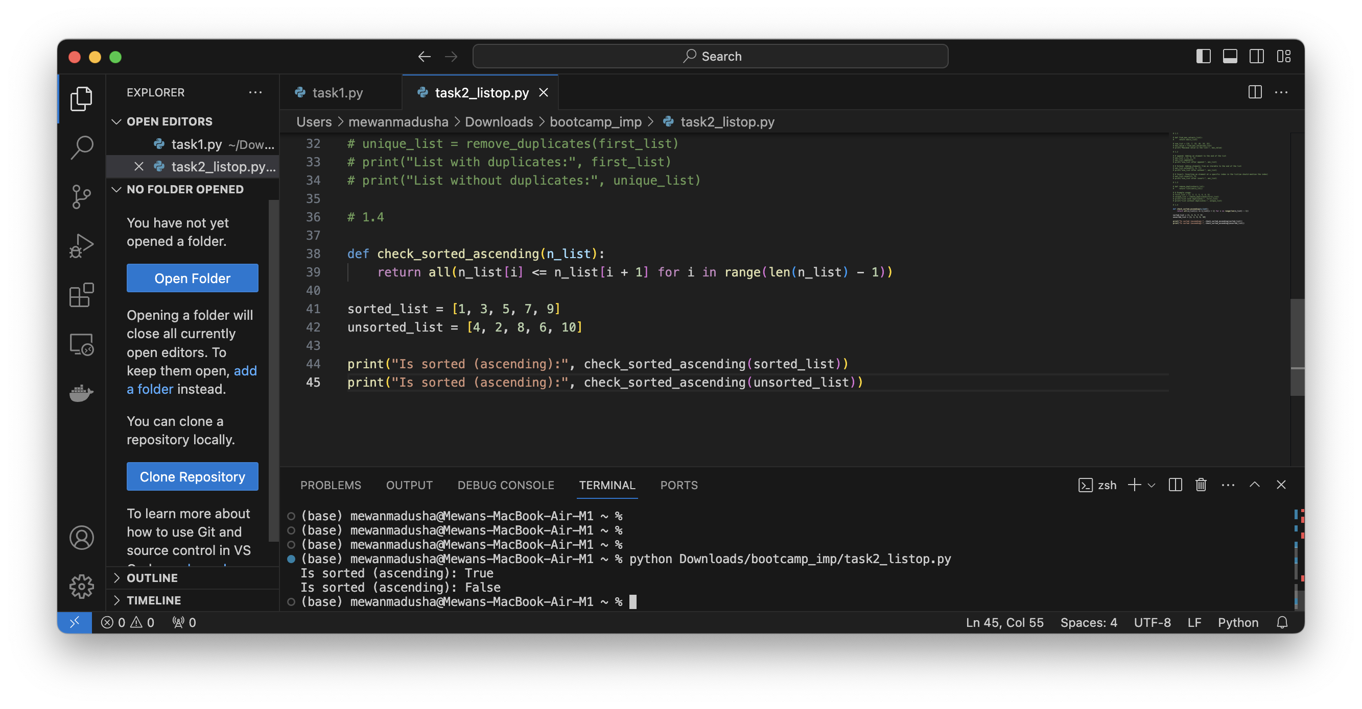

1. Write a program to find the common elements between two lists.

def find_common_elements(list1, list2):

return list(set(list1) & set(list2))

list1 = [1, 2, 3, 4, 5]

list2 = [3, 4, 5, 6, 7]

common_elements_list = find_common_elements(list1, list2)

print("Common elements between two lists:", common_elements_list)

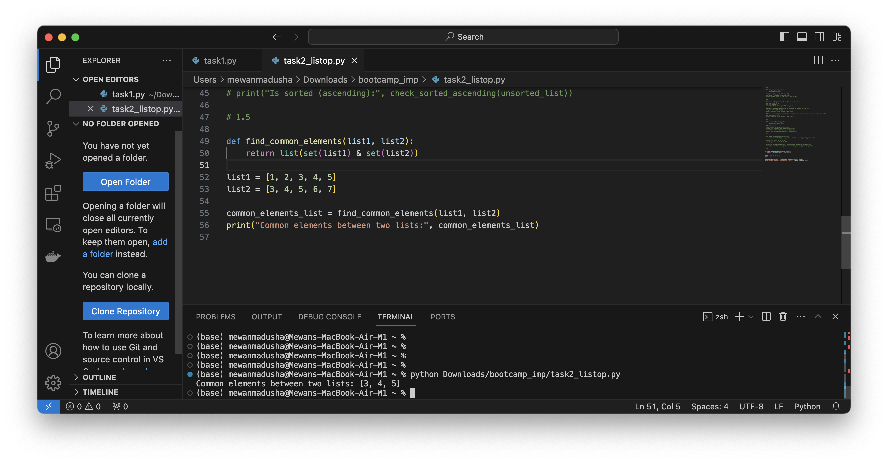

## Dictionary Operations:

1. Create a Python dictionary representing a student's grades (subject: score). Write a function to find the average score.

def find_average_score(grades):

return sum(grades.values()) / len(grades)

student_grades = {'Math': 85, 'English': 90, 'Science': 78, 'History': 92}

avg_score = find_average_score(student_grades)

print("Average score:", avg_score)

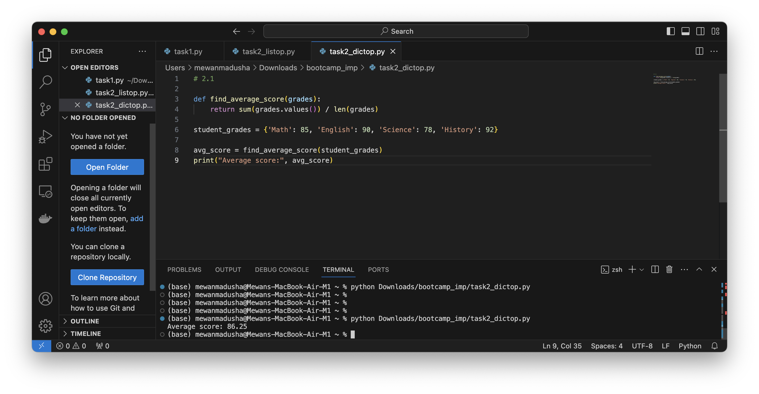

1. Implement a program to merge two dictionaries.

Hear I used dictionary unpacking syntax that available after python 3.5

def merge_dictionaries(dict1, dict2):

merged_dict = {**dict1, **dict2}

return merged_dict

# Example usage:

dict1 = {'a': 'pothumulla', 'b': 'kankanamge'}

dict2 = {'b': 'mewan', 'c': 'madusha'}

merged_dict = merge_dictionaries(dict1, dict2)

# merged_dict = merge_dictionaries(dict2, dict1)

print("Merged dictionary:", merged_dict)

Merged dictionary included all the keys but if there is any common keys, based on the unpacking second dictionary value will be the override value of the merged_dict.

In the below code I also shown both above scenarios.

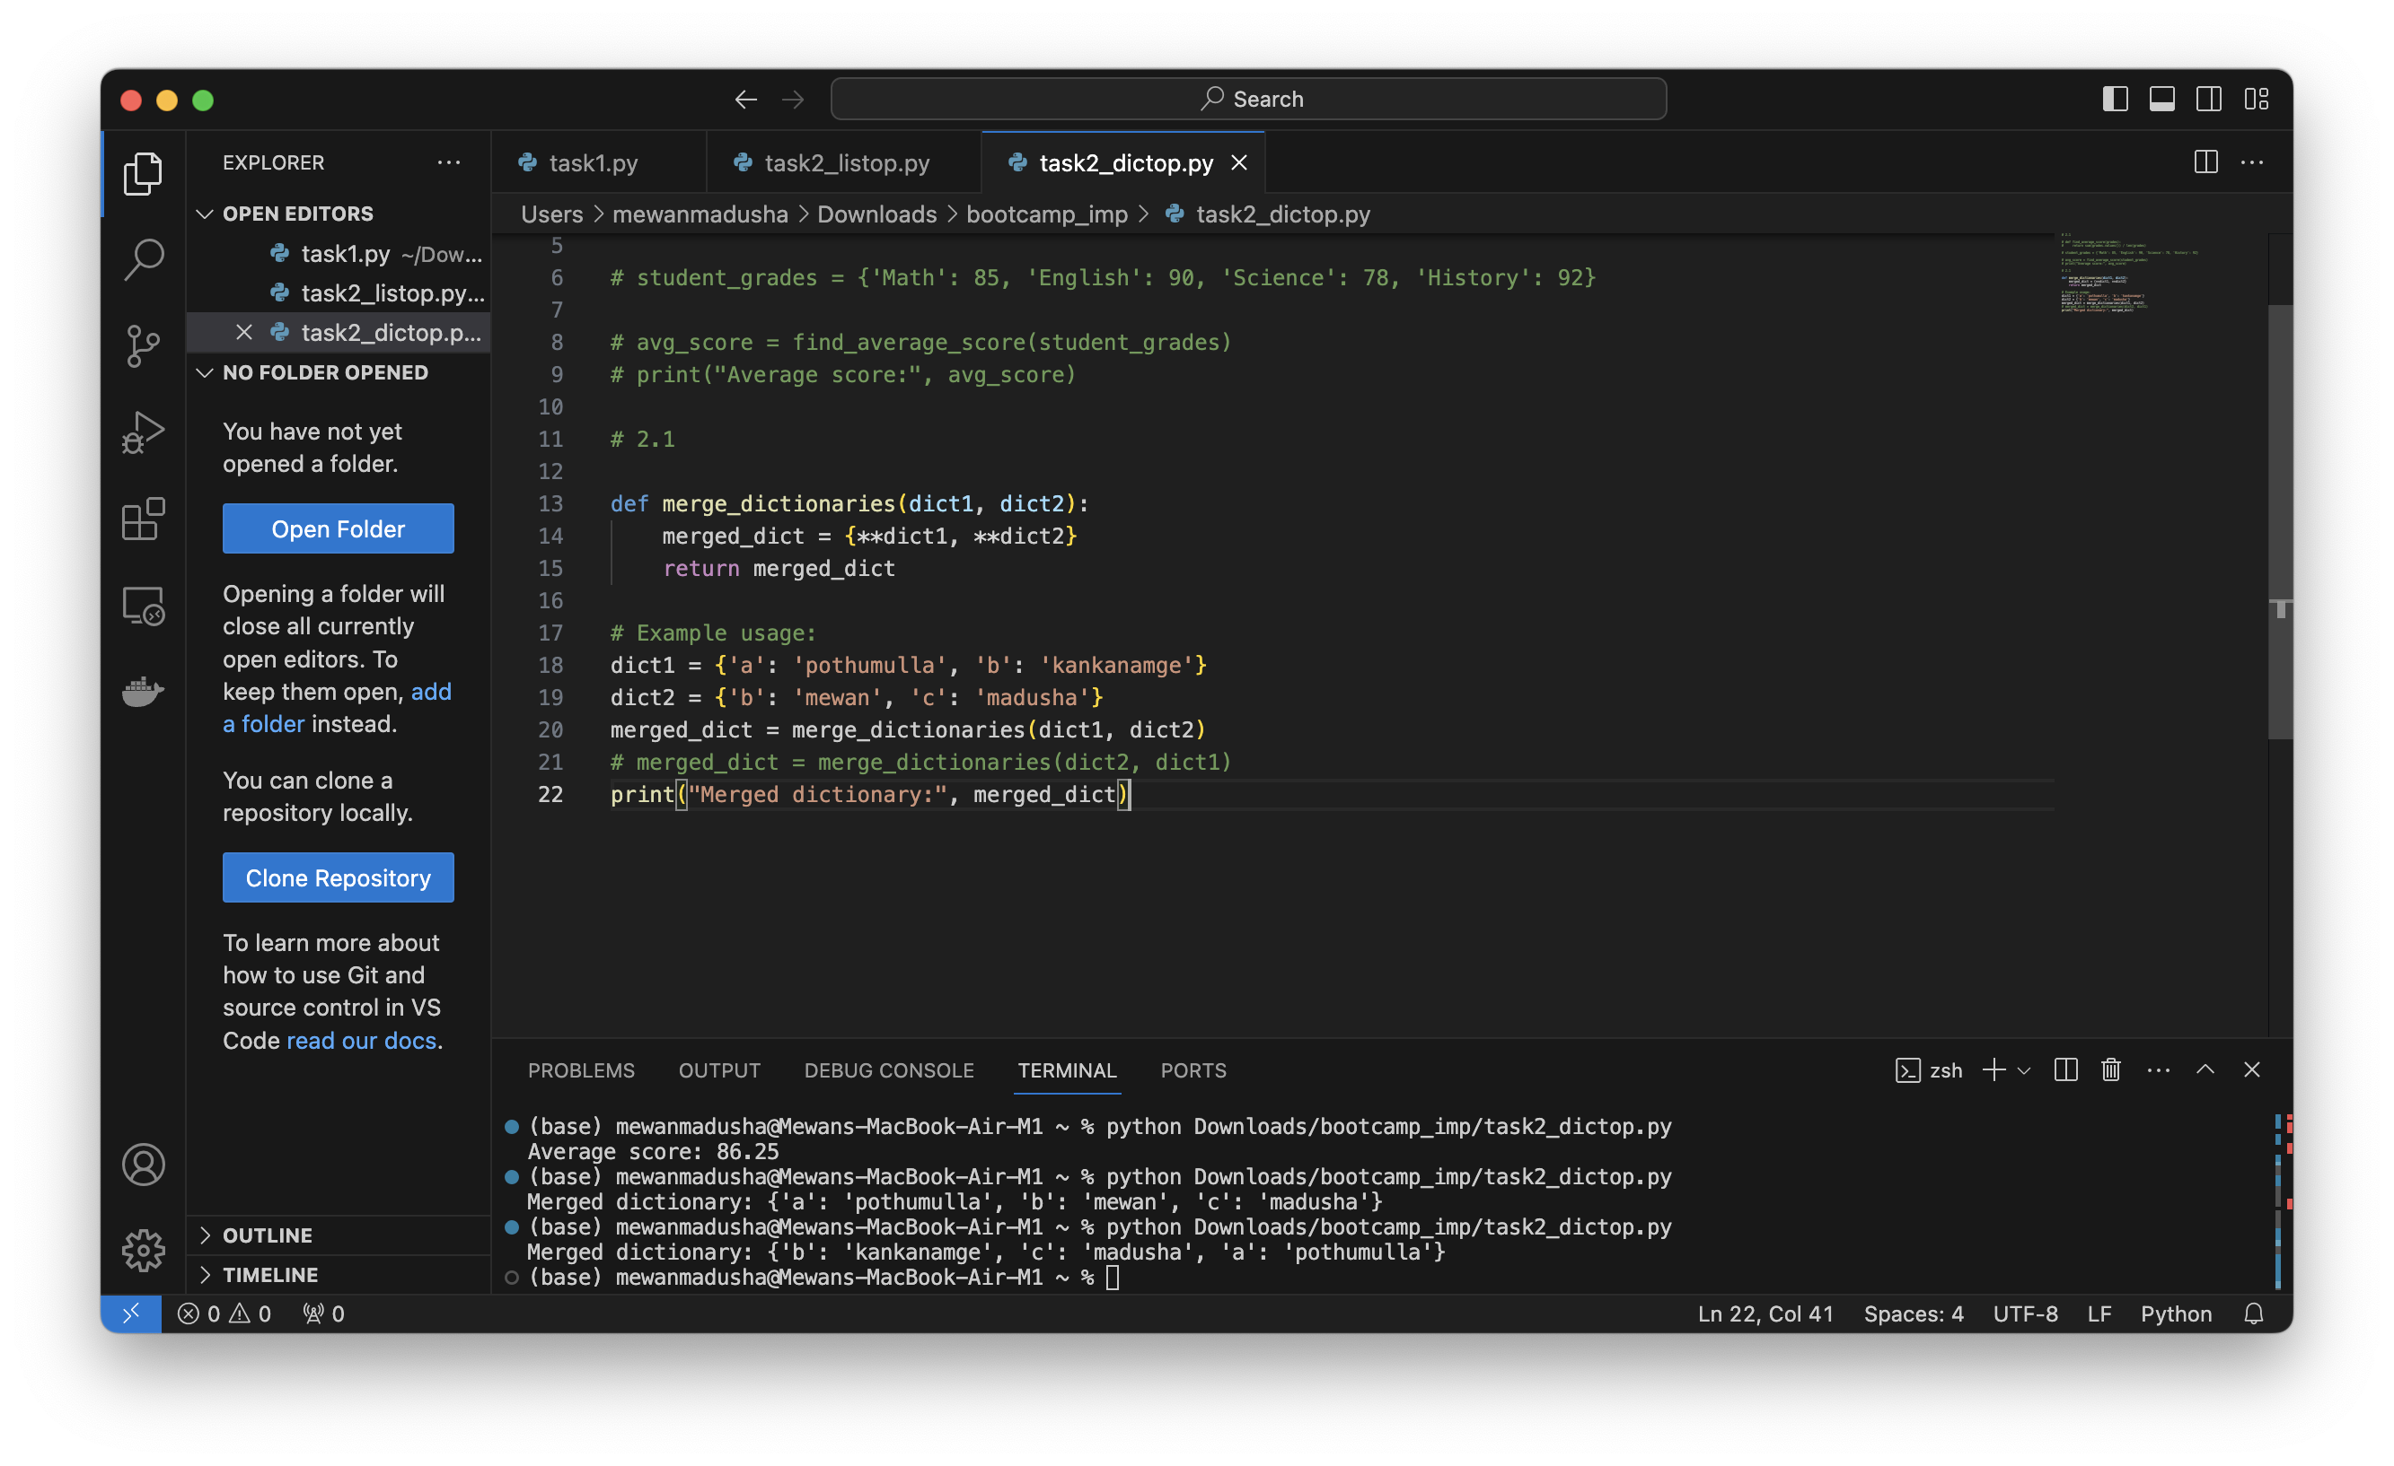

1. Create a program to find the keys with the top N values in a dictionary.

Sorted list returns a new sorted list from the elements of the provided iterable

Iterable is values of dictionary, dictionary.get means sorting based on dictionary values

Reverse=true – sort in to descending order because in the slicing step we can cut out elements from start

[:n] – slicing the list and then get only first N number of elements

Assume n=2

def top_n_keys(dictionary, n):

sorted_keys = sorted(dictionary, key=dictionary.get, reverse=True)

return sorted_keys[:n]

n=2

grades = {'Math': 85, 'English': 90, 'Science': 78, 'History': 92}

top_keys = top_n_keys(grades, n)

print(f"Top {n} keys with highest values: {top_keys}")

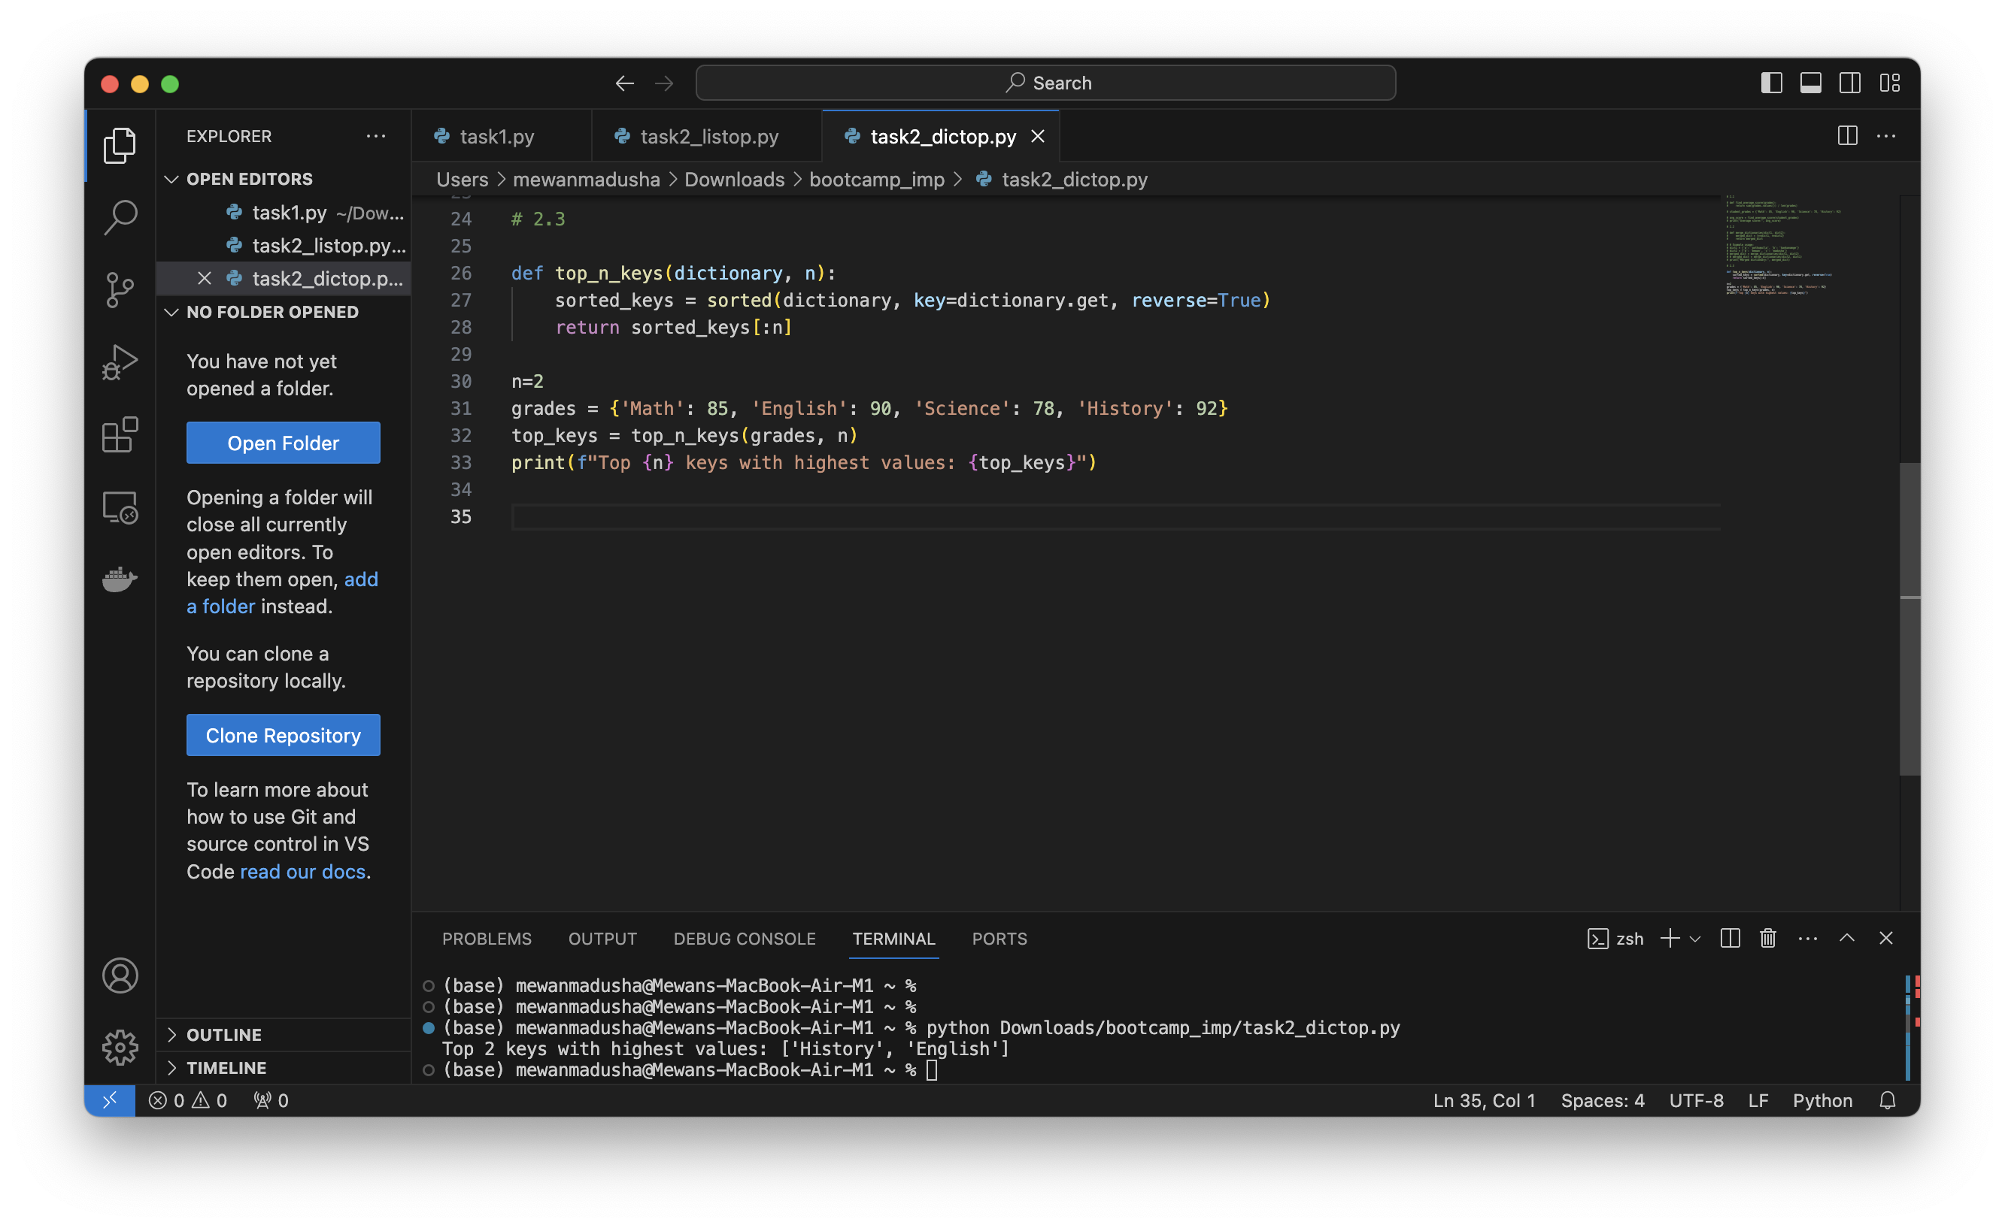

1. Implement a function to sort a dictionary by its values.

def sort_dict_by_values(dictionary):

sorted_dict = dict(sorted(dictionary.items(), key=lambda item: item[1]))

return sorted_dict

unsorted_dict = {'b': 3, 'a': 1, 'c': 4}

sorted_dict = sort_dict_by_values(unsorted_dict)

print("Sorted dictionary by values:", sorted_dict)

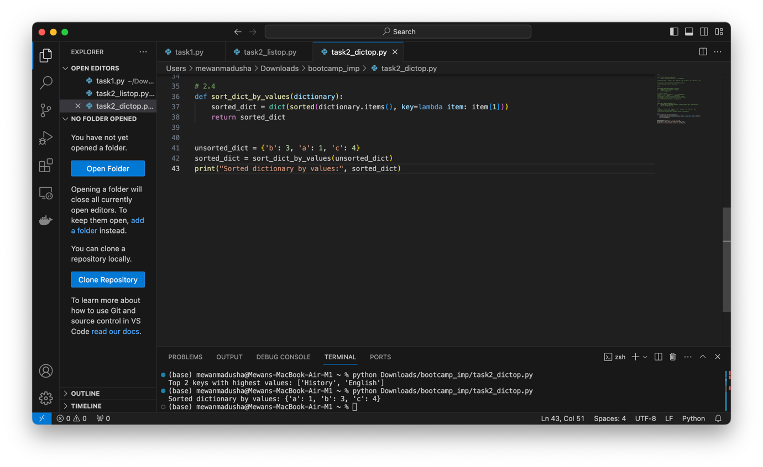

## Combining Lists and Dictionaries:

1. Write a Python program that combines two lists into a dictionary where elements from the first list are keys and elements from the second list are values.

def combine_twolists_to_dict(keys, values):

combined_dict = dict(zip(keys, values))

return combined_dict

keys_list = ['a', 'b', 'c']

values_list = ['mew', 'madusha', 'pothumulla']

result_dict = combine_twolists_to_dict(keys_list, values_list)

print("Dictionary:", result_dict)

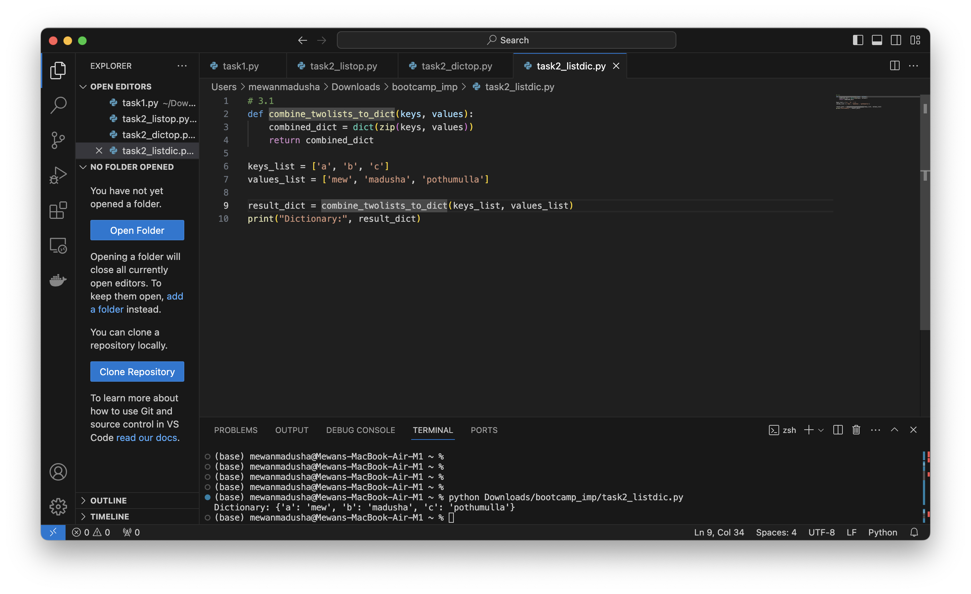

1. Write a program to find the most frequent element in a list and its count.

def get_most_frequent_element(lst):

most_frequent_element = max(set(lst), key=lst.count)

count = lst.count(most_frequent_element)

return most_frequent_element, count

my_list = [1, 2, 2, 3, 3, 3, 4, 4, 4, 4]

most_frequent, count = get_most_frequent_element(my_list)

print(f"Most frequent element: {most_frequent}, Count: {count}")

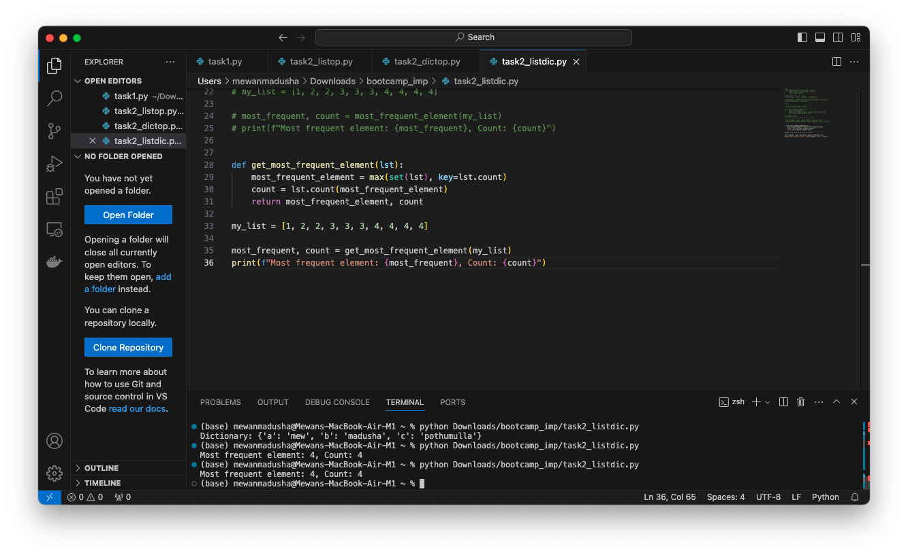

1. Create a program to calculate the total sum of values for each key in a list of dictionaries.

def calculate_total_sum_of_values(list_of_dicts):

result_dict = {}

for d in list_of_dicts:

for key, value in d.items():

result_dict[key] = result_dict.get(key, 0) + value

return result_dict

list_of_dicts = [{'a': 10, 'b': 20}, {'a': 5, 'c': 15}, {'d': 6, 'c': 15}]

sum_of_values = calculate_total_sum_of_values(list_of_dicts)

print("Total sum of values for each key:", sum_of_values)

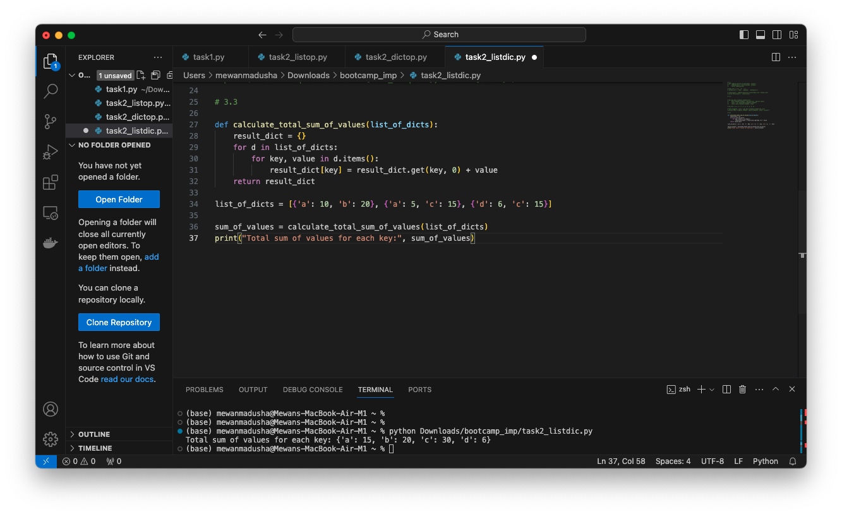

1. Write a Python program to flatten a nested list.

def flatten_nested_list(nested_list):

return [item for sublist in nested_list for item in sublist]

nested_list = [[1, 2, 3], [4, 5, 6], [7, 8, 9]]

flattened_list = flatten_nested_list(nested_list)

print(flattened_list)

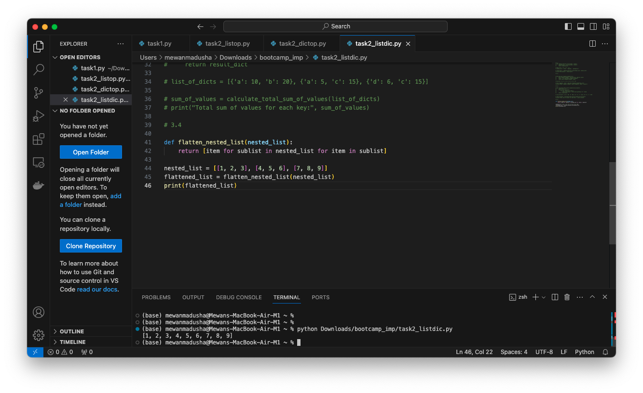

1. Write a function to find the index of the first occurrence of a specific element in a list.

def find_first_occurrence_index(lst, element):

try:

index = lst.index(element)

return index

except ValueError:

return "Unable to find element" # Return None if the element is not found

my_list = [10, 20, 30, 40, 20, 50]

element_to_find = 20

index = find_first_occurrence_index(my_list, element_to_find)

print(f"Index of the first occurrence of {element_to_find}: {index}")

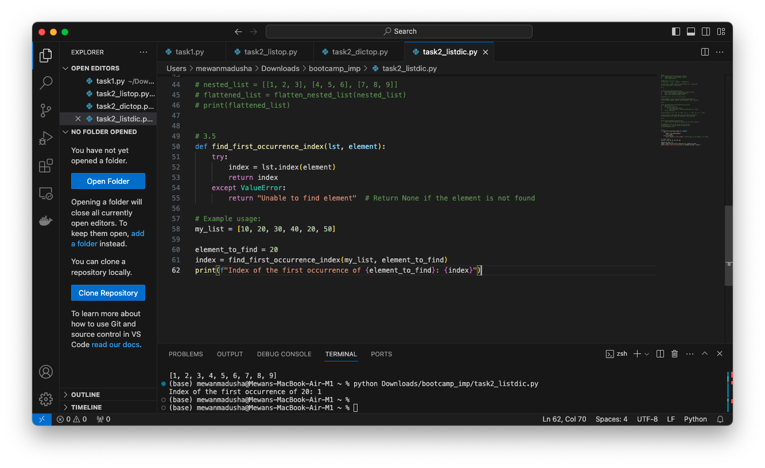

# Extra work(hands-on experience)

## List

list.append(elem) -- adds a single element to the end of the list. Common error: does not return the new list, just modifies the original.

list.insert(index, elem) - inserts the element at the given index, shifting elements to the right.

list.extend(list2) adds the elements in list2 to the end of the list. Using + or += on a list is similar to using extend).

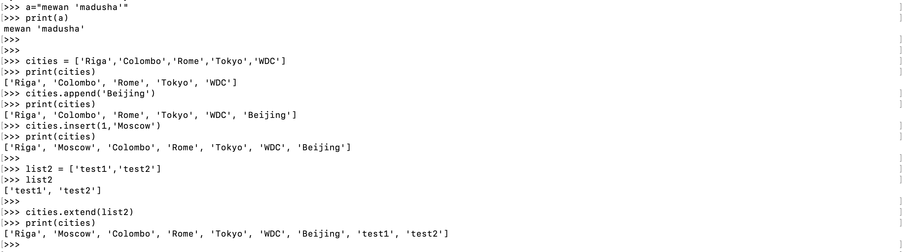

list.indexelem) -- searches for the given element from the start of the list and returns its index. Throws a ValueError if the element does not appear (use "in" to check without a ValueError).



list.remove(elem) -- searches for the first instance of the given element and removes it (throws ValueError if not present)





list.sort() -- sorts the list in place (does not return it). (The sorted) function shown later is preferred.)

list.reverse) -- reverses the list in place (does not return it)

list.pop(index) -- removes and returns the element at the given index. Returns the rightmost element if index is omitted (roughly the opposite of append()).

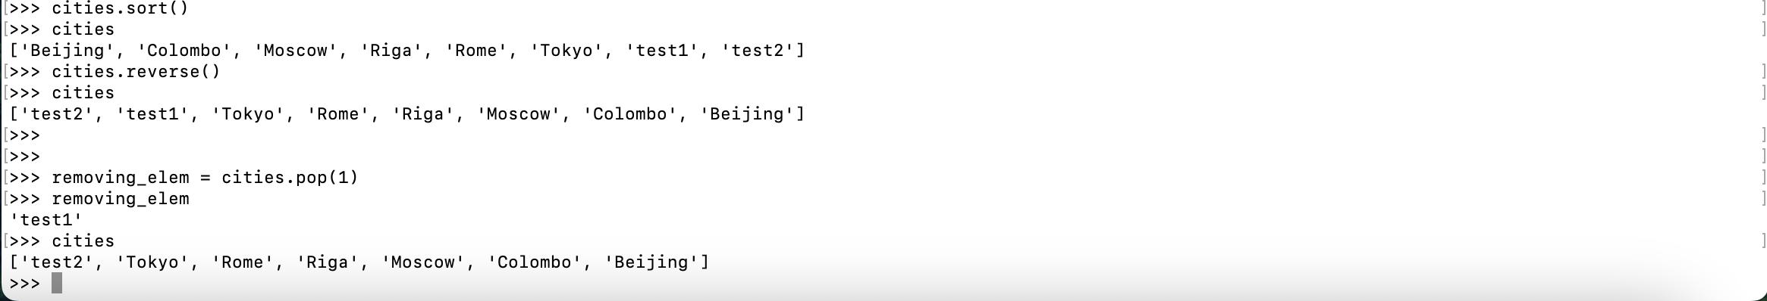

## Dictionary

Dictionary

